OhioKAN Regional Site Application

Thank you for your interest in becoming an Ohio Kinship and Adoption Navigator (OhioKAN) site! This introductory section provides an overview of the application process and what happens after you submit your application here. If you have any questions about this process, you can visit our Overview page here: https://ohiokan.ohio.gov/regional-site-application/

OhioKAN Mission & Values
Kinnect, in partnership with stakeholders across the state and the Ohio Department of Children and Youth, has developed a statewide kinship and adoption navigator program, OhioKAN. The mission of OhioKAN is to provide a statewide, flexible, and responsive kinship and adoption navigator program designed to assist children, caregivers, and families. OhioKAN takes an individualized and genuine approach to partner with families to strengthen their networks. Kinnect and program staff believe that families are inherently capable of finding solutions to the circumstances and challenges they face.

What does it mean to be an OhioKAN site?
Interested community-based, public, and private agencies should complete the application below to be considered as an OhioKAN program site. Selected applicants will employ a full-time OhioKAN Navigator. The Navigators will work with kinship (as defined by O.R.C. 5180.50) and adoptive families to provide support and collaborative services according to the program model in order to improve family functioning and maintain stability for youth. The sites will receive training, coaching, program materials, technical assistance, and evaluation support provided by Kinnect staff to manage the OhioKAN program within their region. Sites must consistently provide the OhioKAN model to fidelity. Interested applicants are encouraged to review the “Affirmations” page at the conclusion of this application to gain a clear understanding of the responsibilities and expectations associated with becoming an OhioKAN site.

How do I submit our application?
Once you have completed your application, you may submit your application electronically by visiting our OhioKAN Application Portal here: https://ohiokan.ohio.gov/regional-site-application/

What happens after I submit?
Kinnect staff will review all application submissions for completeness, making sure full applications move forward in the review process. Kinnect may contact an applicant with missing information to ensure applications are complete. Staff from the Department of Children and Youth, OhioKAN, and Kinnect will review application submissions. Reviewers will score the application using a rubric noting alignment with OhioKAN values and goals, and overall agency and program structure.
The review committee will submit scored applications to Kinnect for final review and in partnership with the Department of Children and Youth and a decision will be made.

Where can I go if I have additional questions?

If you have questions for how to complete this application, please email Britney.Breidenstein@kinnect.org or visit our OhioKAN Application Portal: https://ohiokan.ohio.gov/regional-site-application/

The Application Begins on the Next Page

Step 1: Agency Information
Organization Name:
Organization Point-of-Contact:
Point-of-Contact phone number and email:
Organization address:
County:
Collaborating Organization(s), if Any:
If your application includes formally collaborating with other organization(s)
OhioKAN Regions(s) applying for (map below):
Desired Number of Navigators:
If applying for more than one region, please
indicate how many Navigators per region applying for
Year Organization was founded:
Agency* Budget:
Agency* Staff Size:
Total individuals served last program year:
Does your site currently provide kinship or post-adoptive family services?
* if the applying agency is part of a larger organization, please answer these questions as the local site, rather than the larger organization.

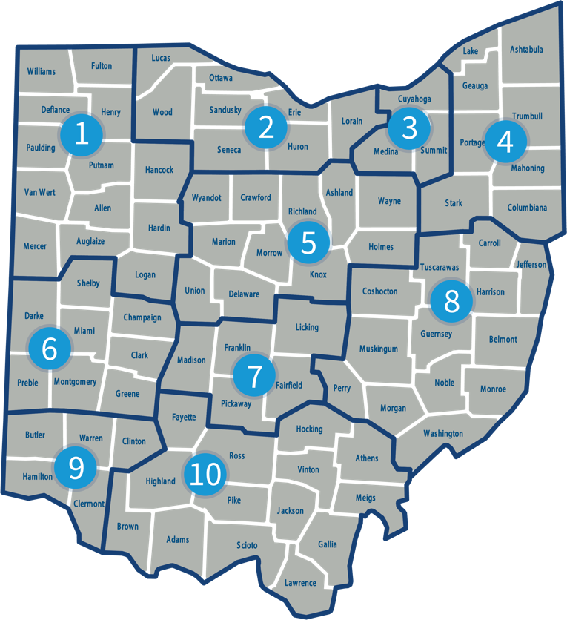

Step 2: Agency Overview

Provide a brief overview of your agency. If your agency is part of a larger state or national organization, share an overview of the entire agency. Include: Mission, values, population served, services provided, etc. (500 word maximum)

Step 3: Program Level
- Why is your organization applying for the OhioKAN program at this time? (300 word maximum)
- Why do you think the OhioKAN program is a good fit for your organization? What about the OhioKAN program aligns with your organization’s mission, values? (300 word maximum)
- If your agency provides kinship and/or post-adoptive services, describe the types of services provided and how long your organization has been serving those families. If you plan to continue providing these services in addition to OhioKAN, how do you plan to maintain the two while upholding OhioKAN’s core components, structure, and stated requirements*? If you do not provide services to kinship and post-adoptive families, how might OhioKAN align with current services? *Please see the attached Performance Framework for guidance with your response. (500 word maximum)
- In reviewing the Performance Framework, please explain how you will adhere to the framework and what supports, if any, you will need to fulfill the objectives and what challenges you foresee, if any. (500 word maximum)
- Where will the OhioKAN Navigator work on a daily basis? Please provide details of the office space they would have, the team they will work with (if applicable), access to internet, supplies, and other necessary work items. If Navigators will be working from home, please provide any information on agency policy for remote work. Will the Navigator be required to come in to pick up supplies, staff meetings, etc.? (300 word maximum)
- Tell us about your strategy for filling the role of the OhioKAN Navigator. Kinnect may request to participate in the interview process for Navigators. What would this collaboration look like? What strengths, challenges, and/or opportunities will you encounter in your effort to recruit someone to fill the role of the OhioKAN Navigator within 45 days of posting? (e.g. union regulations, HR strengths or challenges) (300 word maximum)

Step 4: Agency Level

- Describe your agency’s general approach to supervision and performance management. How would the OhioKAN Navigator position fit within your agency’s approach to supervision? Is a supervisor currently in place to support Navigator(s) at your agency? (300 word maximum)
- Navigators are expected to maintain all records within the OhioKAN databases, including QuickBase and the Ohio Statewide Automated Child Welfare Information System (SACWIS). Administratively, the data in the records are used for evaluation, CQI and quality assurance, which is based on a continuous learning and growth mindset for OhioKAN. Describe any previous experience your agency has collecting standardized data, implementing evidence-based practices, and/or fidelity monitoring. (300 word maximum)
- What internal challenges and barriers do you anticipate should your agency be selected as an OhioKAN site? What strategies can be employed to address these challenges? (300 word maximum)
- Does your agency train staff on trauma-informed care? If so, please describe which staff receive training, if there is specific model that is trained, how frequently the training is offered, and any other information regarding trauma-informed care in the organization? (300 word maximum)
- OhioKAN is committed to principles of individualized engagement, assessment and service delivery. Describe your organization’s commitment to individualized engagement, assessment, and service delivery to promote access to all kinship caregivers.
- What salary range would your agency request for your full-time OhioKAN Navigator? What will the starting salary be for a Navigator at your organization? What is the basis for the minimum salary? Please include the factors and qualifications that may impact this decision? (100 word maximum)
- What does a successful partnership look like to your organization? What elements would need to be present? (300 word minimum)
- We are excited about having you as a potential partner and would love to know more about your organization! If you have them, please provide links to your organization website, any articles/publications or social media sites.

Step 5: Community Level

- In what ways does your organization partner or collaborate with other community and/or governmental organizations (e.g. committee meetings, collaborative projects, MOU’s, shared spaces)? (300 word maximum)
- Give an example of a program or service that your organization provides that requires collaboration with another organization. (300 word maximum)

Step 6: Final Comments

Is there anything else you would like us to know? (300 word maximum)

For Additional Reference

Please find additional information about our program at: https://ohiokan.ohio.gov/ and our Manual at https://manual.ohiokan.org/

Declarations

By signing this page, you are declaring your understanding of the minimum requirements an agency must maintain to be in good standing as an OhioKAN Program site. All OhioKAN sites understand and agree to:

- All of the tenants of the OhioKAN Program Values.
- Maintain a full time Navigator who will follow the OhioKAN model and will have no other responsibilities in the agency.
- Adhere to the principles of OhioKAN’s individualized engagement, assessment and service.
- Navigators work an eight-hour shift that will fall within the program operating hours of 8:30-6:30, Monday through Friday. Any and all overtime will be discussed with OhioKAN regional staff prior to approval.
- Navigator(s) maintaining all records in SACWIS, and other data systems as needed, and will not require maintenance of OhioKAN records elsewhere at the agency.
- Allow Navigator(s) and Supervisor to participate in all required OhioKAN trainings and Learning Communities.
- Navigator salary and benefits be paid at the typical rate of other employees in the agency. Kinnect will reimburse the Agency within thirty (30) days after the later of Kinnect’s receipt of the required information for the same calendar month (As noted in the MOU, invoices are due the 5th business day of each month). A delay in reimbursement to the Agency may occur, or reimbursement to the Agency may not be paid, if the Agency is not in compliance with its obligations under this Agreement and/or under the Program. Kinnect shall not be obligated to provide such payment to the Agency until DCY has completed their review of the Invoice and provided reimbursement payment to Kinnect.
- Assume responsibility of all human resources activities of the Navigator, but any disciplinary actions, resignations, and salary adjustments must be communicated to your state and regional OhioKAN leadership.
- Implement the OhioKAN model as developed and maintain fidelity to the model. Any difficulties implementing, maintaining fidelity, or adaptations to the model must be communicated to OhioKAN leadership.
- Willingly participate in evaluation and continuous quality improvement activities, including timely data entry and provision of reports as needed.

By signing below, I agree that my agency will be able to meet these minimum requirements, and that further requirements will be addressed through an MOU if chosen as an OhioKAN site.

Signature Date

Name and Title

